
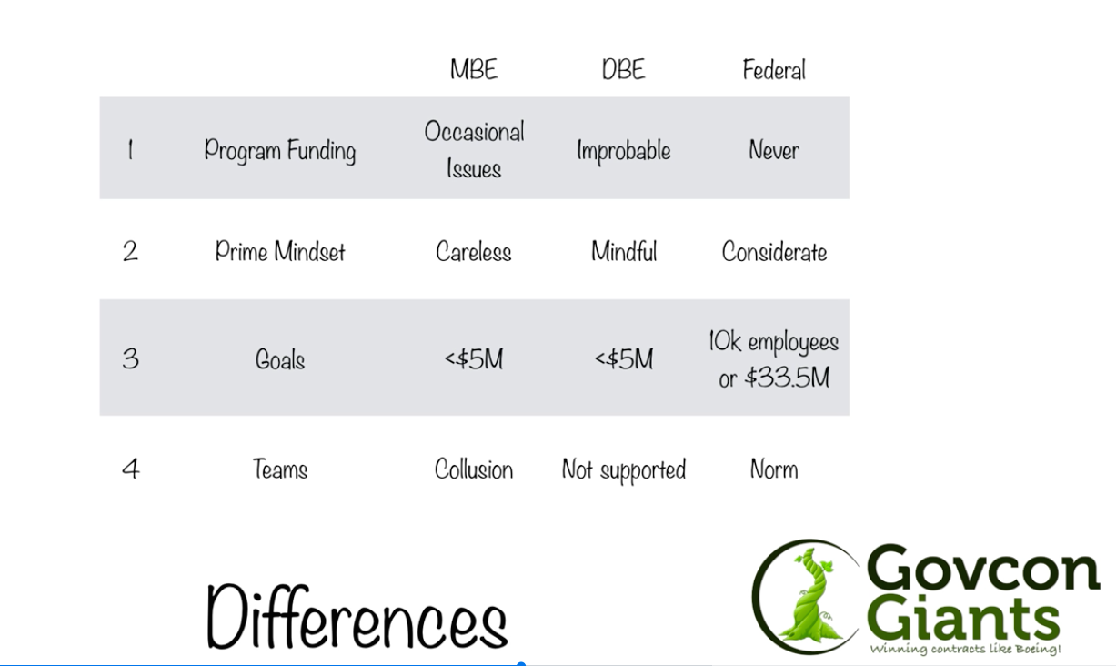
ASSIGNMENT /HOMEWORK
-----------------------

Start Here:
Ever watched the movie ‘War Dogs’ it’s just like that.

What kind of stuff do they buy?

Homework:
Today’s homework is a fun assignment.

Day #1 WHAT IS A
GOVERNMENT CONTRACT
-----------------------
Welcome to " How to Win Government Contracts Course!" Day #1

We are excited to have you here with us while we embark on this 18-day journey.

You are not alone. In fact right now there are 100’s of people going through this course along with you. By the time you finish you’ll get a chance to meet some of them and maybe even do potential deals with them.

In order to get unusual results (wealth, success, fortune) you must do unusual things. By taking this first step you are doing something that normal people don’t do.

If knowledge is power, you’re about to become a military tank.

ASSIGNMENT #1 - WATCH

If you have any questions or are confused about a topic please click the Question button and someone will respond.

Complete Assignment #1 below

QUESTION

